

**Tech shop project**

**Software Design Specification**

– Hanoi, August 2022 –

Record of changeS

|  |  |  |  |
| --- | --- | --- | --- |
| Date | A* M, D | In charge | Change Description |
|  |  |  |  |
|  |  |  |  |
|  |  |  |  |
|  |  |  |  |
|  |  |  |  |
|  |  |  |  |
|  |  |  |  |
|  |  |  |  |
|  |  |  |  |
|  |  |  |  |
|  |  |  |  |
|  |  |  |  |
|  |  |  |  |

*A - Added M - Modified D - Deleted

**Table of Contents**

I. Overview 4

1. Code Packages 4

2. Database Design 4

a. Database Schema 4

b. Table Description 4

II. Code Designs 5

1. <Feature/Function Name1> 5

a. Class Diagram 5

b. Class Specifications 5

c. Sequence Diagram(s) 5

d. Database queries 6

2. <Feature/Function Name2> 6

# I. Overview

## 1. Code Packages

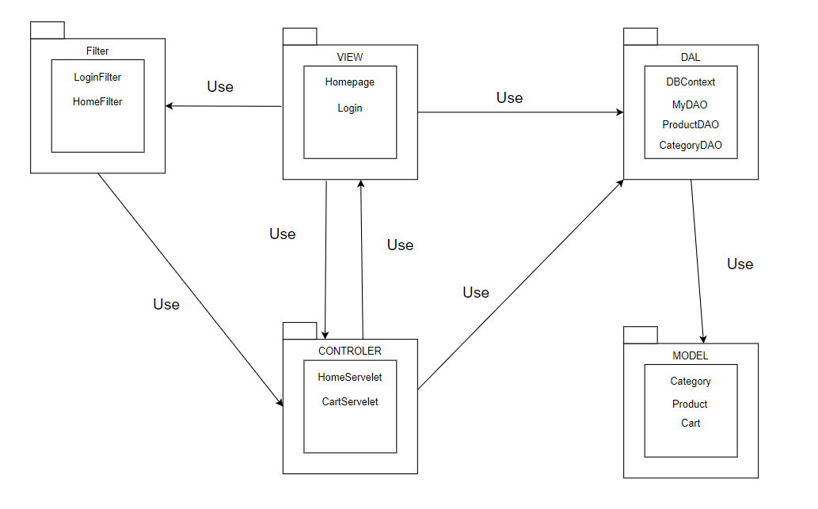

***Package descriptions***

|  |  |  |
| --- | --- | --- |
| **No** | **Package** | **Description** |
| *01* | *View(web page)* | *Provide interaction with user ,GUI*  *Java Class Naming Convention* |
| *02* | *Controler* | *Control the data flow between view and dal (DAO),Control the logic of the system* |
| *03* | *Dal* | *Provide the connection to the Database, Extract data for the system* |
| *04* | *Model* | *Define the logic of data extracted from Database Java Class Naming Convention* |
| *05* | *Filter* | *Control the redirection between Pages in View and from View to Controller Java Class Naming Convention* |

## 2. Database Design

### a. Database Schema



### b. Table Description

|  |  |  |
| --- | --- | --- |
| **No** | **Table** | **Description** |
| *01* | *Blog* | *Blog content, title, image url*  *-Primary key: Id*  *-Foreign keys: userId* |
| *02* | *UserStatus* | *Account activation status (actived, locked, unverified)*  *-Primary key: Id* |
| *03* | *Role* | *Role of user (admin, sale, customer,marketing)*  *-Primary key: Id* |
| *04* | *Users* | *Users*  *-Primary key: UserId*  *-Foreign keys: RoleId, StatusId* |
| *05* | *City* | *-Primary key: Id* |
| *06* | *District* | *-Primary key: Id* |
| *07* | *ShipAddress* | *Address to take product*  *-Primary key: Id*  *-Foreign keys: UserId, ShipCityId, DistrictId* |
| *08* | *Category* | *-Primary key: Id* |
| *09* | *ProductStatus* | *Status for product(available, stopbusiness)*  *-Primary key: StatusId* |
| *10* | *Brand* | *Brand of a product*  *-Primary key: BrandId* |
| *11* | *Product* | *-Primary key: ProductId*  *-Foreign keys: CatId, SellerId, StatusId, BrandId* |
| *12* | *ProductImg* | *Product image url*  *-Primary key: Id*  *-Foreign keys: ProductId* |
| *13* | *Cart* | *Cart info for each user*  *-Primary key: Id*  *-Foreign keys: ProductId, UserId* |
| *14* | *OrderStatus* | *Info for order(packaging,canceled, completed)*  *-Primary key: Id* |
| *15* | *Orders* | *Order for each product*  *-Primary key: Id*  *-Foreign keys: UserId, StatusId* |
| *16* | *OrderDetail* | *-Primary key: Id*  *-Foreign keys: OrderId, ProductId* |
| *17* | *ShipInfo* | *Address for shipping product*  *-Primary key: Id*  *-Foreign keys: OrderId, ShipAddressId* |
| *18* | *Notification* | *Notification data*  *-Primary key: Id*  *-Foreign keys: UserId, OrderId* |
| *19* | *Feedback* | *Feedback of a product*  *-Primary key: Id*  *-Foreign keys: UserId, ProductId* |
| *20* | *Blog* | *Blog of a user*  *-Primary key: Id*  *-Foreign keys: UserId* |

# II. Code Designs

## 1. <Feature/Function Name1>

*[Provide the detailed design for the function <Feature/Function Name1>. It include Class Diagram, Class Specifications, and Sequence Diagram(s)]*

### a. Class Diagram

*[This part presents the class diagram for the relevant feature]*

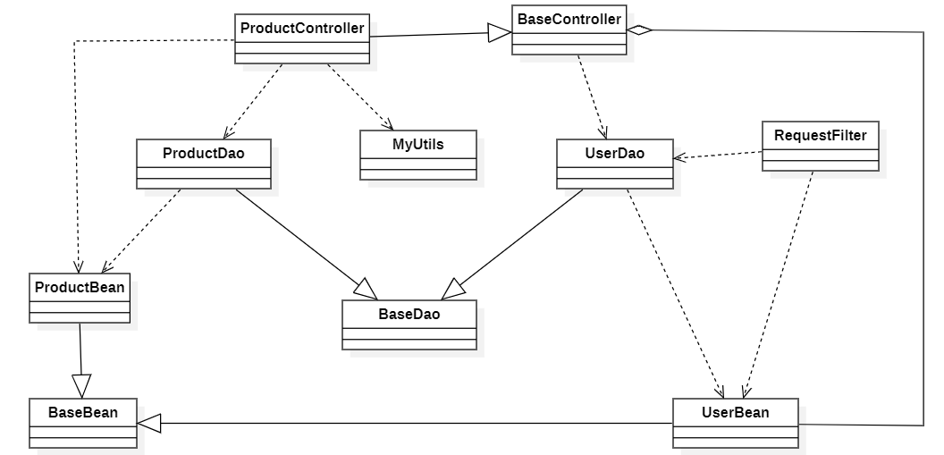

### b. Class Specifications

*[Provide the description for each class and the methods in each class, following the table format as below]*

#### XYZ Class

*[Provide the detailed description for the class methods]*

|  |  |  |
| --- | --- | --- |
| **No** | **Method** | **Description** |
| *01* | *<method name>* | *<Description of the method, including the inputs, outputs & internal method processing>* |
|  |  |  |

#### ABC Class

***Class Methods***

*[Provide the detailed description for the class methods]*

|  |  |  |
| --- | --- | --- |
| **No** | **Method** | **Description** |
| *01* | *<method name>* | *<Description of the method, including the inputs, outputs & internal method processing>* |
|  |  |  |

### c. Sequence Diagram(s)

*[Provide the sequence diagram(s) for the feature, see the sample below]*

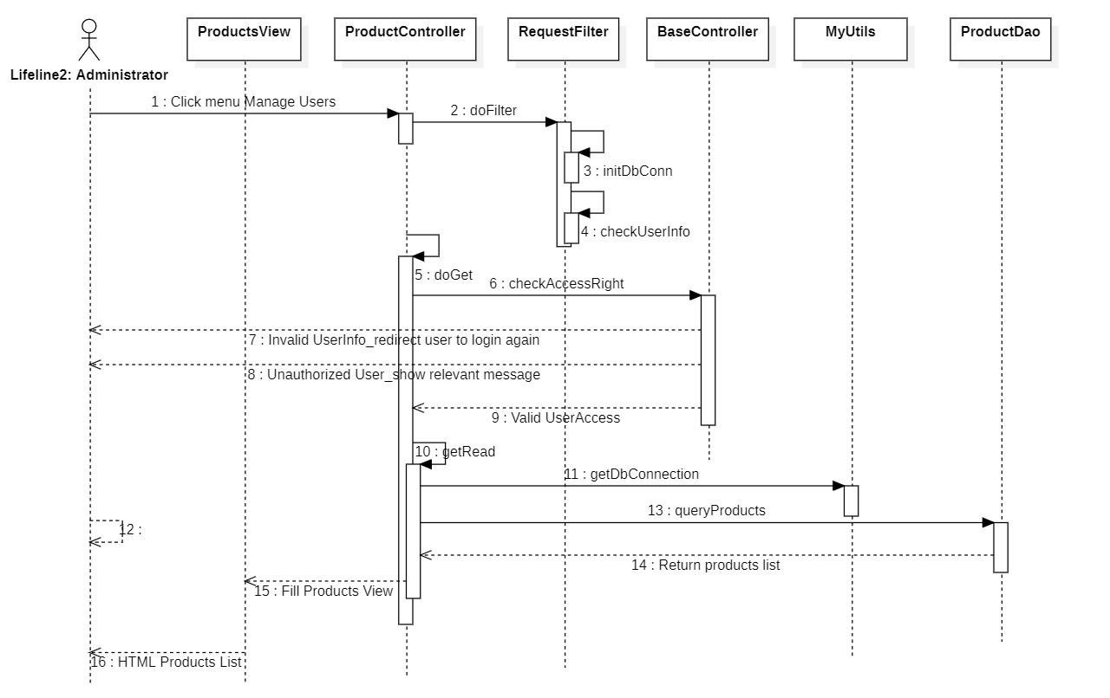

### d. Database Queries

*[Provide the detailed SQL (select, insert, update...) which are used in implementing the function/screen]*

## 2. <Feature/Function Name2>

…